**1999 Nordic Tug 37**

**Wiper Rebuild**

**Prices 1/8/2015**

AM Equipment [www.amequipment.com](http://www.amequipment.com) Butch Helland

402 Hazel Street 541-327-3362 541-327-1546

Jefferson, OR 97352

1. **Part #304 - 1203**, 51mm – 2” Pivot shaft. $33.51.

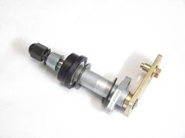

1. **Part #305 - 1007**, 230 Series Pantograph Adapter, 1.75” (44.45mm) C/L Spacing. $16.96.

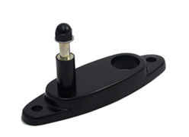

1. **Part #352 – 0098**, 19” Pantograph Arm – Dry – Tapered Knurl. $70.85.

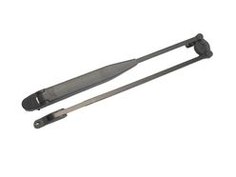

1. **Part #302 – 1170**, 17” (430mm) Standard Wiper Blade w/Adapter. $14.45. 